Name: Swarnabh Paul

Section: Y

Roll no: 19CS8122

Assignment no: 1

Questions attempted: a,b,c,d,e

**Question (a)**

**Code:**

#include<iostream>

#include<fstream>

#include<string>

#include<algorithm>

using namespace std;

string **largeAdd**(string,string);

**int** **main**()

{

string n1, n2, res;

cout<<"Input first number: ";

cin>>n1;

cout<<"Input second number: ";

cin>>n2;

res=largeAdd(n1,n2);

cout<<"Result is: "<<res;

ofstream fout;

fout.open("sum.txt",ios::out);

fout<<res;

fout.close();

**return** **0**;

}

string **largeAdd**(string n1,string n2)

{

**int** l1=n1.length(), l2=n2.length(), c=**0**, i=**0**;

string res="";

reverse(n1.begin(),n1.end());

reverse(n2.begin(),n2.end());

**while**(i<l1&&i<l2)

{

res+=(**char**)(((c+(**int**)((n1[i]-'0')+(n2[i]-'0')))%**10**)+'0');

c=(c+(**int**)((n1[i]-'0')+(n2[i]-'0')))/**10**;

i++;

}

**while**(i<l1)

{

res+=(**char**)(((c+(**int**)(n1[i]-'0'))%**10**)+'0');

c=(c+(**int**)(n1[i]-'0'))/**10**;

i++;

}

**while**(i<l2)

{

res+=(**char**)(((c+(**int**)(n2[i]-'0'))%**10**)+'0');

c=(c+(**int**)(n2[i]-'0'))/**10**;

i++;

}

**if**(c)

{

res+=(**char**)(c+'0');

}

reverse(res.begin(),res.end());

**return** res;

}

**Output:**

Input first number: 2345

Input second number: 9876

Result is: 12221

**Question (b)**

**Code:**

#include<iostream>

#include<stdio.h>

#include<string>

#include<string.h>

using namespace std;

string **copyString**(**char**\*);

**void** **display**(string[],**int**);

**void** **indent**(string name)

{

**FILE** *f=fopen(name.c_str(),"r");

**if**(f==NULL)

{

cout<<"File does not exist.";

**return**;

}

string s[**1000**];

**char** temp[**1000**];

**int** n=**0**, i, tab=**0**;

**while**(fgets(temp,**1000**,f)!=NULL)

{

s[n]=copyString(temp);

**if**(s[n][**0**]=='}')

{

tab--;

}

**for**(i=**0**;i<tab;i++)

s[n]='\t'+s[n];

**if**(s[n][tab]=='{')

{

tab++;

}

n++;

}

fclose(f);

display(s,n);

f=fopen("indent.c","w");

**for**(i=**0**;i<n;i++)

fprintf(f,"%s",s[i].c_str());

fclose(f);

}

**int** **main**()

{

string s;

cout<<"Enter filename to be scanned (with extension): ";

cin>>s;

indent(s);

**return** **0**;

}

string **copyString**(**char** *temp)

{

**int** i, n=strlen(temp);

string s;

**for**(i=**0**;i<n;i++)

s+=temp[i];

**return** s;

}

**void** **display**(string s[],**int** n)

{

**int** i;

cout<<"Displaying indented code:**\n\n**";

**for**(i=**0**;i<n;i++)

cout<<s[i];

}

**Output:**

Enter filename to be scanned (with extension): FirstC++Code(FarenheitToCelsius).cpp

Displaying indented code:

#include<iostream>

#include<conio.h>

using namespace std;

int main()

{

int far;

float cel;

char ch;

do

{

cout<<"Enter temperature in farenheit: ";

cin>>far;

cel=(float) (far-32)*(5.0/9);

cout<<far<<" far = "<<cel<<" cel"<<endl;

cout<<"Want to continue: <y/n> ";

cin>>ch;

}while(ch=='y'||ch=='Y');

return 0;

}

**Question (c)**

**Code:**

#include<iostream>

#include<stdlib.h>

#include<time.h>

#include<iomanip>

**unsigned** **long** **int** **myrand**(**unsigned** **long** **int**);

using namespace std;

**int** **main**()

{

**unsigned** **long** **int** myRandNum, sysRandNum, myseed;

**int** o1[**5**], o2[**5**];

**double** chi1, chi2;

**time_t** seconds;

**int** n, i;

seconds=time(NULL);

cout<<"The time as seed: "<<seconds<<endl;

myseed=seconds;

srand(seconds);

cout<<"How many numbers?: ";

cin>>n;

cout<<setw(**40**)<<"Nos. generated by myrand()"<<setw(**40**)<<"Nos. generated by rand()"<<endl;

**for**(**int** i=**0**;i<**5**;i++)

o1[i]=o2[i]=**0**;

**for**(**int** i=**1**;i<=n;i++)

{

myseed=myrand(myseed);

myRandNum=(myseed%**50**)+**1**;

sysRandNum=(rand()%**50**)+**1**;

cout<<setw(**40**)<<myRandNum<<setw(**40**)<<sysRandNum<<endl;

**if**(myRandNum<=**10**)

o1[**0**]++;

**else** **if**(myRandNum<=**20**)

o1[**1**]++;

**else** **if**(myRandNum<=**30**)

o1[**2**]++;

**else** **if**(myRandNum<=**40**)

o1[**3**]++;

**else**

o1[**4**]++;

**if**(sysRandNum<=**10**)

o2[**0**]++;

**else** **if**(sysRandNum<=**20**)

o2[**1**]++;

**else** **if**(sysRandNum<=**30**)

o2[**2**]++;

**else** **if**(sysRandNum<=**40**)

o2[**3**]++;

**else**

o2[**4**]++;

}

chi1=chi2=**0.0**;

**for**(i=**0**;i<**5**;i++)

{

chi1+=(((o1[i]-(n/**5.0**))*(o1[i]-(n/**5.0**)))/(n/**5.0**));

chi2+=(((o2[i]-(n/**5.0**))*(o2[i]-(n/**5.0**)))/(n/**5.0**));

}

cout<<"Chi square test value of random nos. generated by myrand(): "<<chi1<<endl;

cout<<"Chi square test value of random nos. generated by rand(): "<<chi2<<endl;

**if**(chi1<**23.6**)

cout<<"Chi square test value of myrand() is acceptable."<<endl;

**else**

cout<<"Chi square test value of myrand() is not acceptable."<<endl;

**if**(chi2<**23.6**)

cout<<"Chi square test value of rand() is acceptable."<<endl;

**else**

cout<<"Chi square test value of rand() is not acceptable."<<endl;

**return** **0**;

}

**unsigned** **long** **int** **myrand**(**unsigned** **long** **int** x)

{

**unsigned** **long** **long** **int** m=**2147483647**, a=**65539**;

**unsigned** **long** **int** r=(x*a)%m;

**return** r;

}

**Output:**

The time as seed: 1612588779

How many numbers?: 20

Nos. generated by myrand() Nos. generated by rand()

24 44

30 35

2 41

13 40

4 9

35 40

34 19

20 13

16 43

14 16

15 13

6 18

15 46

9 6

48 34

27 33

16 35

3 10

2 10

2 34

Chi square test value of random nos. generated by myrand(): 8

Chi square test value of random nos. generated by rand(): 6.5

Chi square test value of myrand() is acceptable.

Chi square test value of rand() is acceptable.

**Question (d)**

**Code:**

#include<iostream>

#include<math.h>

#include<iomanip>

using namespace std;

**void** **plotCosine**();

**void** **plotExponential**();

**int** **main**()

{

**int** choice;

cout<<"Enter choice:**\n**1. Plot cosine**\n**2. Plot exponential**\n**";

cin>>choice;

**for**(**int** i=**0**;i<=**110**;i++)

cout<<'=';

cout<<endl;

**if**(choice==**1**)

plotCosine();

**else** **if**(choice==**2**)

plotExponential();

**else**

cout<<"Wrong choice.";

**return** **0**;

}

**void** **plotCosine**()

{

**int** a, b, s, x, i;

**char** c;

cout<<"Enter the starting angle (in degrees): "; cin>>a;

cout<<"Enter the ending angle (in degrees): "; cin>>b;

cout<<"Enter the step length: "; cin>>s;

cout<<"Enter the fill character: "; cin>>c;

**for**(i=a;i<=b;i+=s)

{

x=floor(cos(i\***3.14**/**180**)\***50**);

**if**(x>=**0**)

{

cout<<setw(**55**)<<setfill(' ')<<'|'<<setw(x)<<setfill(c)<<'+'<<endl;

}

**else**

{

x=abs(x);

cout<<setw(**55**-x)<<setfill(' ')<<'+'<<setw(x)<<setfill(c)<<'|'<<endl;

}

}

}

**void** **plotExponential**()

{

**int** a, b, s, x, i;

**char** c;

cout<<"Enter the starting coordinate: "; cin>>a;

cout<<"Enter the ending coordinate: "; cin>>b;

cout<<"Enter the step length: "; cin>>s;

cout<<"Enter the fill character: "; cin>>c;

**for**(i=a;i<=b;i+=s)

{

x=floor(exp(i));

**if**(x>**100**)

x=**100**;

cout<<setw(**5**)<<setfill(' ')<<'|'<<setw(x)<<setfill(c)<<'+'<<endl;

}

}

**Output(1):**

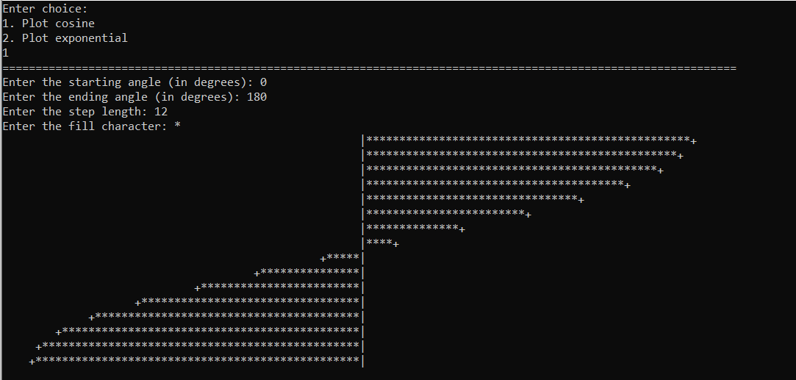

**Output(2):**

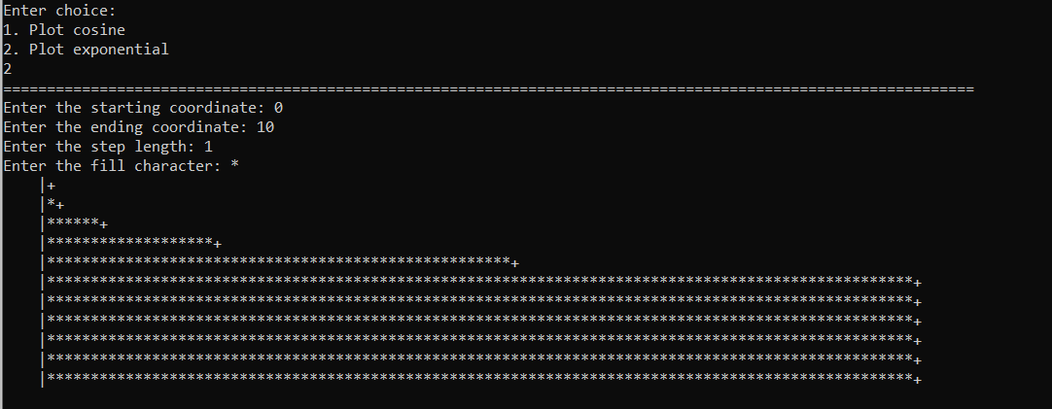

**Question (e)**

**Code:**

#include<iostream>

#include<iomanip>

using namespace std;

**void** **printPattern**(**int**);

**int** **main**()

{

**int** n, i, j;

cout<<"Enter n: ";

cin>>n;

printPattern(n);

**return** **0**;

}

**void** **printPattern**(**int** n)

{

**int** i, j;

**for**(i=**1**;i<=n;i++)

{

cout<<setw(i)<<i;

**for**(j=i+**1**;j<=n;j++)

cout<<j;

j--;

**while**(j>i)

{

j--;

cout<<j;

}

cout<<endl;

}

**for**(i=**1**;i<n;i++)

{

cout<<setw(n-i)<<n-i;

**for**(j=n-i+**1**;j<=n;j++)

cout<<j;

j--;

**while**(j>n-i)

{

j--;

cout<<j;

}

cout<<endl;

}

}

**Output:**

Enter n: 5

123454321

2345432

34543

454

5

454

34543

2345432

123454321

**Extra Question (To find the factorial of a very large number n)**

**Code:**

#include<iostream>

#include<string>

#include<algorithm>

using namespace std;

string **factorial**(**int**);

string **multiply**(string,**int**,**int**\*);

**int** **main**()

{

**int** n;

cout<<"Input n: ";

cin>>n;

string result=factorial(n);

cout<<"Result is: "<<result<<endl;

**return** **0**;

}

string **factorial**(**int** n)

{

string result="1";

**int** len=**1**, i;

**for**(i=**1**;i<=n;i++)

result=multiply(result,i,&len);

reverse(result.begin(),result.end());

**return** result;

}

string **multiply**(string s,**int** x,**int** *len)

{

**int** i, d, c=**0**;

**for**(i=**0**;i<(*len);i++)

{

d=(**int**(s[i]-'0'))*x+c;

c=d/**10**;

d%=**10**;

s[i]=**char**(d+'0');

}

**while**(c)

{

s+=**char**((c%**10**)+'0');

c/=**10**;

(*len)++;

}

**return** s;

}

**Output:**

Input n: 100

Result is: 93326215443944152681699238856266700490715968264381621468592963895217599993229915608941463976156518286253697920827223758251185210916864000000000000000000000000